School of Communication

[Title]

UTS CRICOS 00099F

UTS TEQSA PRV12060



92553 Complex Exercise Management

**Laboratory Manual 2025**

UTS CRICOS 00099F

UTS TEQSA PRV12060

**School of Sport, Exercise & Rehabilitation**

University of Technology Sydney



Faculty of  
Arts & Social  
Sciences

UTS CRICOS 00099F

UTS TEQSA PRV12060



[Title]

UTS CRICOS 00099F

UTS TEQSA PRV12060

Faculty of Arts  
& Social Sciences

[Title]

School of   
Communication

UTS CRICOS 00099F

UTS TEQSA PRV12060

School of  
 Communication

UTS CRICOS 00099F

UTS TEQSA PRV12060

[Title]



Faculty of  
Arts & Social  
Sciences

[Title]

UTS CRICOS 00099F

UTS TEQSA PRV12060



Faculty of  
Arts & Social  
Sciences

[Title]

UTS CRICOS 00099F

UTS TEQSA PRV12060

[Title]

Faculty of Arts   
& Social Sciences

UTS CRICOS 00099F

UTS TEQSA PRV12060

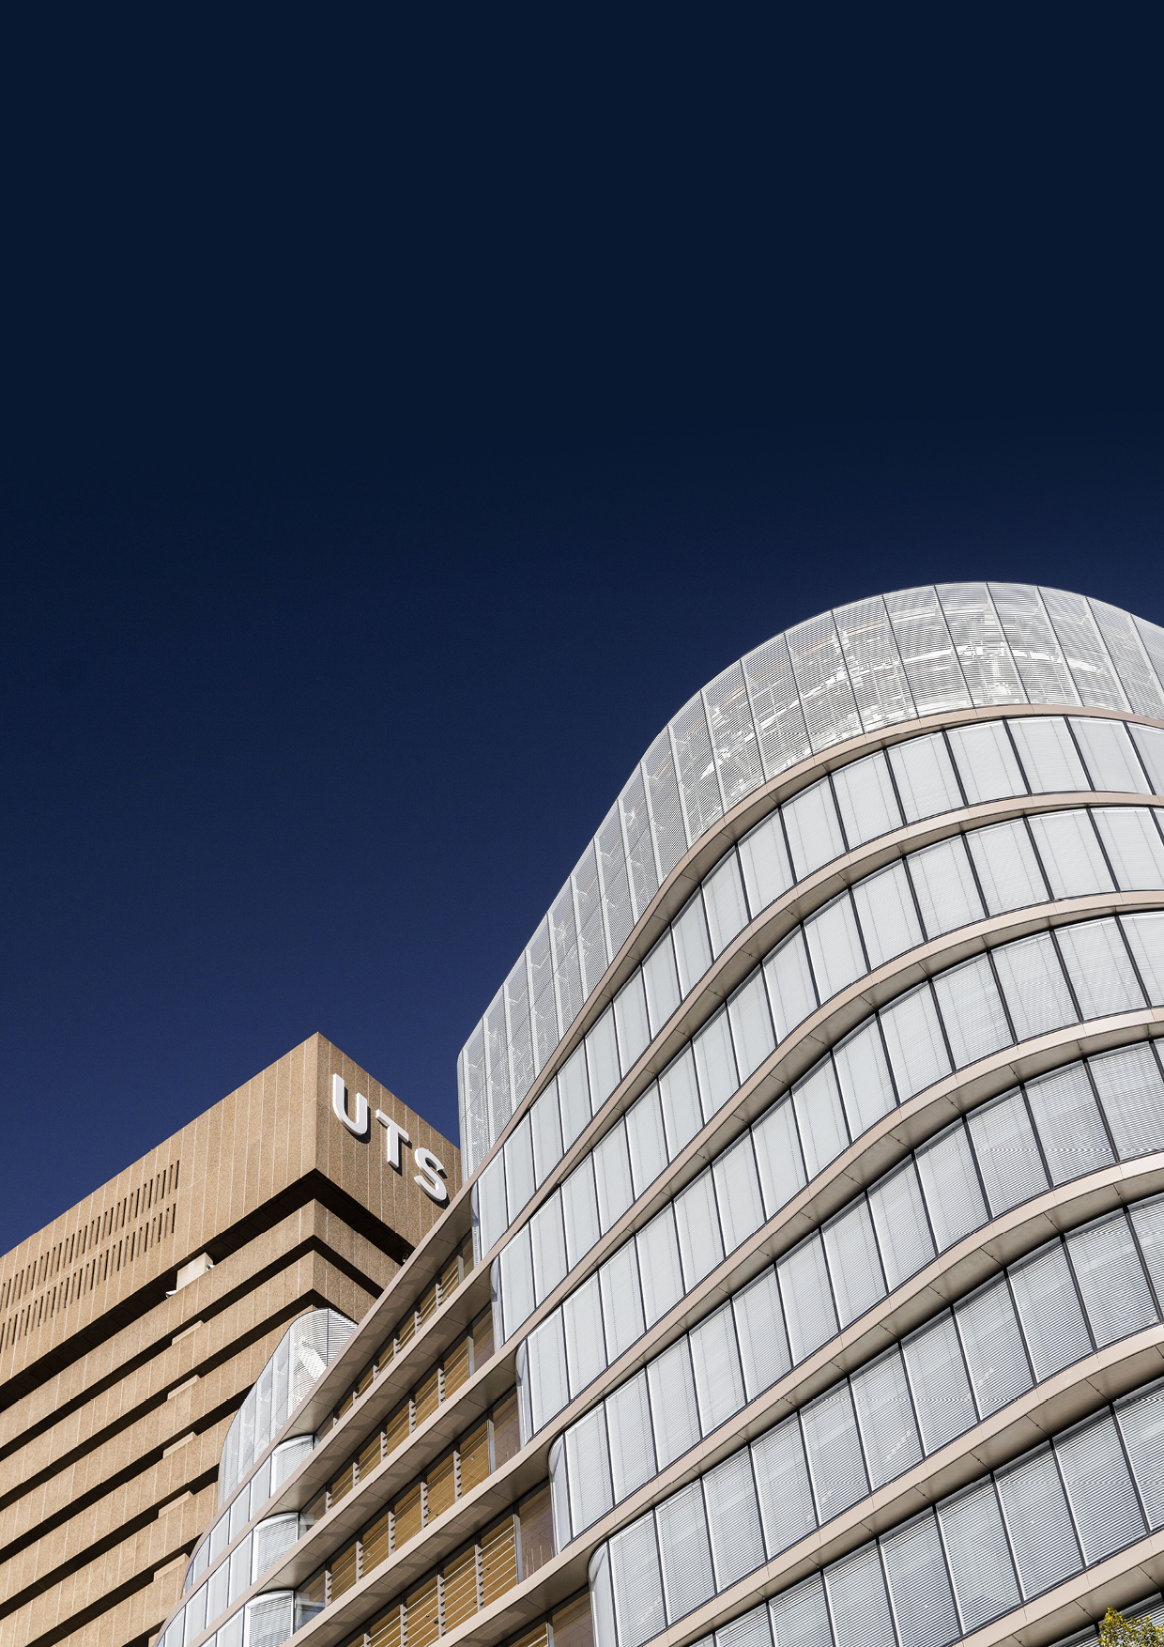­

School of  
 Communication

[Title]

UTS CRICOS 00099F

UTS TEQSA PRV12060

You can change the image on this cover:

* Select the first full page image (overlaying shapes) and ‘Send to back’
* Now click the photograph and under the ‘Shape Fill’ choose ‘Picture’
* Finally, select the photograph and ‘Send to back’.

**DELETE THIS INSTRUCTIONAL BOX BEFORE FINALISING YOUR DOCUMENT.**

[Title]

Faculty of Arts

& Social Sciences

UTS CRICOS 00099F

UTS TEQSA PRV12060

UTS CRICOS 00099F

UTS TEQSA PRV12060

[Title]

Faculty of  
Arts & Social  
Sciences

Section break

Contents

Text styles (Heading 1) 1

Heading 2 1

Heading 3 1

1 Nbr Heading 1 2

1.1 Nbr Heading 2 2

1.1.1 Nbr Heading 3 2

Tables 3

Figures

**No table of figures entries found.**

Tables

Table 1: Shaded Blue Table 3

Table 2: Lined Blue Table 3

Table 3: Shaded Red Table 3

Table 4: Lined Red Table 3

Table 5: Shaded Black Table 3

Table 6: Lined Black Table 3

# Text styles (Heading 1)

The most commonly used style is **Body Text**. It has been formatted differently to the Normal text style, which is a basic single-line-spaced style. It is important to select Body Text for the bulk of the content as it has pre-set before and after spacing and expanded line spacing to create consistent paragraph spacing. Enter down and type on the very next line – an automatic paragraph.

## Heading 2

* **List Bullet** style is set up to continue indenting and switching between styles of bullets
  + ‘Tab’ at the start of a bullet to get to the next bullet indent and style
    - ‘Shift Tab’ to move back to the previous bullet and style
      * There are five bullet levels
        + This is the final bullet at 3cm.

1. List Paragraph has been set up in a level system to indent at pre-set tab points. By using the ‘Tab’ key you can indent the list paragraph by 0.75cm each point.
2. These indents are used to align paragraphs under the ‘List Bullet’ and ‘List Number’ styles. Use ‘Tab’ to move to the next level, use ‘Shift Tab’ to move to the previous level.

### Heading 3

Body Text body text body text body text body text body text body text body text body text.

1. **List Number** style is set up to continue indenting and switching between styles of numbering
   1. ‘Tab’ at the start of a number to get to the next number indent and style
      1. ‘Shift Tab’ to move back to the previous number and style
         1. If you need to manually restart the list numbering, place the cursor over the number, right-click and select ‘Restart at 1’.
            1. This is the final number at 3cm.

#### Heading 4

Body text body text body text body text body text body text body text body text body text body text.

1. **List Alpha** style is set up to continue indenting and switching between styles of numbering
   1. ‘Tab’ at the start of a number to get to the next number indent and style
      1. ‘Shift Tab’ to move back to the previous number and style
         1. If you need to manually restart the list numbering, place the cursor over the number, right-click and select ‘Restart at 1’.
            1. This is the final number at 3cm.
2. Nbr Heading 1

The most commonly used style is **Body Text**. It has been formatted differently to the Normal text style, which is a basic single-line-spaced style. It is important to select Body Text for the bulk of the content as it has pre-set before and after spacing and expanded line spacing to create consistent paragraph spacing. Enter down and type on the very next line – an automatic paragraph[1].

* 1. Nbr Heading 2
* **List Bullet** style is set up to continue indenting and switching between styles of bullets
  + ‘Tab’ at the start of a bullet to get to the next bullet indent and style
    - ‘Shift Tab’ to move back to the previous bullet and style
      * There are five bullet levels
        + This is the final bullet at 3cm.

1. List Paragraph has been set up in a level system to indent at pre-set tab points. By using the ‘Tab’ key you can indent the list paragraph by 0.75cm each point.
2. These indents are used to align paragraphs under the ‘List Bullet’ and ‘List Number’ styles. Use ‘Tab’ to move to the next level, use ‘Shift Tab’ to move to the previous level.
   * 1. Nbr Heading 3

Body Text body text body text body text body text body text body text body text body text.

1. **List Number** style is set up to continue indenting and switching between styles of numbering
   1. ‘Tab’ at the start of a number to get to the next number indent and style
      1. ‘Shift Tab’ to move back to the previous number and style
         1. If you need to manually restart the list numbering, place the cursor over the number, right-click and select ‘Restart at 1’.
            1. This is the final number at 3cm.
         2. Nbr Heading 4

Body text body text body text body text body text body text body text body text body text body text.

1. **List Alpha** style is set up to continue indenting and switching between styles of numbering
   1. ‘Tab’ at the start of a number to get to the next number indent and style
      1. ‘Shift Tab’ to move back to the previous number and style
         1. If you need to manually restart the list numbering, place the cursor over the number, right-click and select ‘Restart at 1’.
            1. This is the final number at 3cm.

# Tables

Table : Shaded Blue Table

|  |  |  |  |
| --- | --- | --- | --- |
| Table Heading | Table Heading | Table Heading | Table Heading |
| Table Text | Table Text | Table Text | Table Text |
| 1. Table Number | 1. Table Number | 1. Table Number | 1. Table Number |
| * Table Bullets | * Table Bullets | * Table Bullets | * Table Bullets |

Table : Lined Blue Table

|  |  |  |  |
| --- | --- | --- | --- |
| Table Heading | Table Heading | Table Heading | Table Heading |
| Table Text | Table Text | Table Text | Table Text |
| Table Text | Table Text | Table Text | Table Text |
| Table Text | Table Text | Table Text | Table Text |

Table : Shaded Red Table

|  |  |  |  |
| --- | --- | --- | --- |
| Table Heading | Table Heading | Table Heading | Table Heading |
| Table Text | Table Text | Table Text | Table Text |
| Table Text | Table Text | Table Text | Table Text |
| Table Text | Table Text | Table Text | Table Text |

Table : Lined Red Table

|  |  |  |  |
| --- | --- | --- | --- |
| Table Heading | Table Heading | Table Heading | Table Heading |
| Table Text | Table Text | Table Text | Table Text |
| Table Text | Table Text | Table Text | Table Text |
| Table Text | Table Text | Table Text | Table Text |

Table : Shaded Black Table

|  |  |  |  |
| --- | --- | --- | --- |
| Table Heading | Table Heading | Table Heading | Table Heading |
| Table Text | Table Text | Table Text | Table Text |
| Table Text | Table Text | Table Text | Table Text |
| Table Text | Table Text | Table Text | Table Text |

Table : Lined Black Table

|  |  |  |  |
| --- | --- | --- | --- |
| Table Heading | Table Heading | Table Heading | Table Heading |
| Table Text | Table Text | Table Text | Table Text |
| Table Text | Table Text | Table Text | Table Text |
| Table Text | Table Text | Table Text | Table Text |

1.